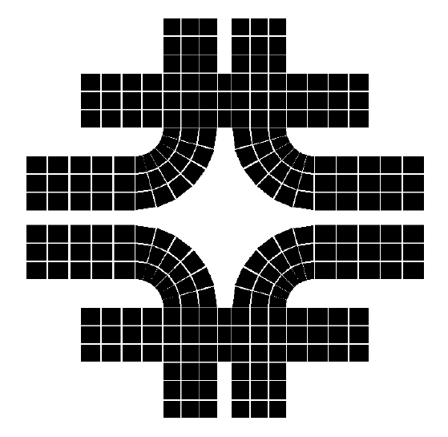
A Structure Analysis For the Sphere Tank Support
PPD/MD/Engineering Analysis Group
Fermilab
Used as the Reactor Neutrino Detector
In the Braidwood Experiment
Ang Lee & Hans Jostlein
September 1st, 2004

Abstract
A steel column structure for the detector support has been studied. The analysis indicates that the deflection and stress is relative small under the operating condition (1g load) and still within its allowable even for a possible 2 g loading during the transporting. The structure can also tolerate some imbalance from the hydraulic support system. It is a simple system and easy to build.

Introduction & Modeling
A steel sphere tank, with a diameter of 6.8 m, is filled with the mineral oil. It weighs about 157 ton and is supported by four steel columns as shown in Figure 1, proposed by Hans Jostlein. The spherical tank has a 6 mm wall thickness.
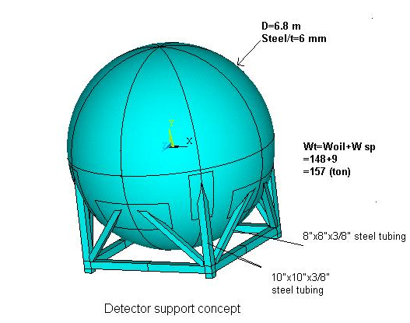
A 3-D finite element model has been created with an 8-nodes shell element. A linear distributed hydrostatic pressure is applied at the inner surface of the tank ranging from p=0 at the top to p=8.7 psi at the bottom as shown in Figure 2. The vertical and horizontal columns are assumed to be 10”x10”x3/8” steel columns. The diagonal members are 8”x8”x3/8”. The steel pad between the columns and the tank is 0.5” thick. Since each column will sit on a Hillman Roller, the boundary condition for the vertical column is to constrain it vertically only (free to move horizontally).
Figure 1 Sketch of the Detector Support

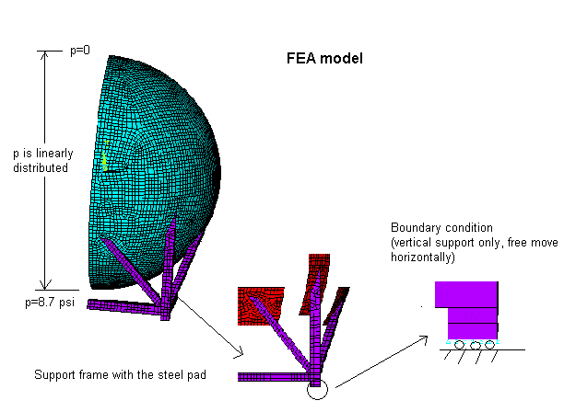
Figure 2 The FEA Model and Boundary Condition

Result & Discussion
a) Case 1: Fully supported -- operating case (1 g load)
The calculation shows that the maximum vertical deflection is about 28 mils (0.75 mm). The maximum tangential deflection (in-plane) along circumference direction (Y axis) is less than 2 mils and 22 mils (0.55 mm) along “top to bottom” direction, respectively. The table 1 is a summary of the calculation result. The deflection and stress plot is attached at Appendix B. The stress is well below to its allowable, which can be defined as 60% of the yield stress:
a) For the steel tank and pad, an A36 or similar common steel will gives
$σ(\text{allowable})=0\text{.}6∗\text{36},\text{000}$=24,000 psi (tank and pad)
b) For the steel column with a yield stress around 46,000 psi, it gives
$σ(\text{allowable})=0\text{.}6∗\text{46},\text{000}$=27,000 psi (steel column)

Table-1 The Summary of the Calculation Result for a Fully

Supported case __ Operating Case

 | Sphere | Steel Pad | Steel Column
Stress(psi) | <4,200 | <7,000 | <12,000
Allowable (psi) | 21,000 | 21,000 | 27,000

The buckling calculation based on ASIC shows that a single 10”x10” x3/8” column can resist up to 286 (kips)=130 (ton) force shown in Appendix A. There is enough safety factor against the column buckling.

b) Case II: One corner drops 1/16”
As a further study, we have looked at the case in which one corner drops down 1/16” to see whether the proposed structure will experience any damages. The result is shown on the table 2. It seems not a problem although the stress goes up to 7,300 psi for the steel tank and to 8,300 psi for the steel pad. It indicates that the system could tolerate some imbalance from the hydraulic system. The stress and deflection plot is attached at Appendix B.

Table 2 The Stress for the Case Which Drops

One Corner Down 1/16”
 | Sphere | Steel Pad | Steel Column
Stress(psi) | <7,300 | <8,300 | <18,000

C) Case III: One of the supports completely drops out (three supports -- accident case)

As a hypothetic study, we extend the case II to the extreme condition where one leg support completely drops out, to see what will happen to the structure. The calculation shows that the maximum vertical deflection of the structure is about 0.1322” (1/8”). The maximum stress for the spherical tank goes up to 11,000 psi and 12,000 psi for the steel pad, respectively. The stress for the column is still within its allowable as shown in table 3. The structure integrity has not been compromised even with one of the supports missing. However, this is an accident case which should not be used as a guideline for the design and operation.

Table –3 The Stress for the Case Which Drops One Corner

Completely__ Accident Case
 | Sphere | Steel Pad | Steel Column
Stress(psi) | <11,000 | <12,000 | <25,000

Conclusion:
In conclusion, the study shows that the proposed structure is quite adequate for the purpose of supporting the 157(tons) tank. The maximum deflection is less than 0.75 mm. The stress is relatively low for the 1 g-load. For the case of transporting the structure with a possible 2-g load, the stress can be predicted by simply doubling the stress from table 1(case 1). It is still within its allowable. The study also indicates that the structure will be able to tolerate a 1/16” imbalance from hydraulic cylinder and that the structure integrity has not been compromised even with one of the supports completely missing.

Appendix A: Buckling Calculation for the steel column

“Steel Construction Manual”, Ninth Edition, Chapter E “Columns and Other Compression Member”:
For 10”x10”x3/8” the steel column with 46,000 psi yield stress,
A=14.10 in²; I=214 in⁴; r=3.90 in, E=29E3 (ksi); Fy=46 (ksi)

$$\begin{aligned}C_{c}=\sqrt{\frac{2∗π^{2}∗E}{F_{y}}}=\sqrt{\frac{2∗π^{2}∗\text{29}E^{3}}{\text{46}}}=\text{112} \\ \\ \end{aligned}$$
and

$$\frac{K∗L}{r}=2∗\text{150}\text{\} over \{3 }.\text{ 9}=\text{76}\text{.}9\text{\} \{}$$

The Equation E2-1 gives an allowable compressive force Fa

$$F_{a}∗A=\frac{(1−\frac{({\text{kl}}/r)^{2}}{2C_{c^{2}}})F_{y}}{(5/3)+\frac{3({\text{kl}}/r)}{8C_{c}}−\frac{({\text{kl}}/r)^{3}}{8C_{c^{3}}}}=\text{286}(\text{kips})$$

for a single 10”x10”x3/8” column.

The total weight of filled tank is 157 ton x2200=346 (kips). The operation force for each column will be

346/4=87 kips<< 286 kips given by ASIC code.

Appendix B: Stress and Deflection Plot for case I, case II and case III

1) Case 1: Fully support case__ operating case (1 G load)
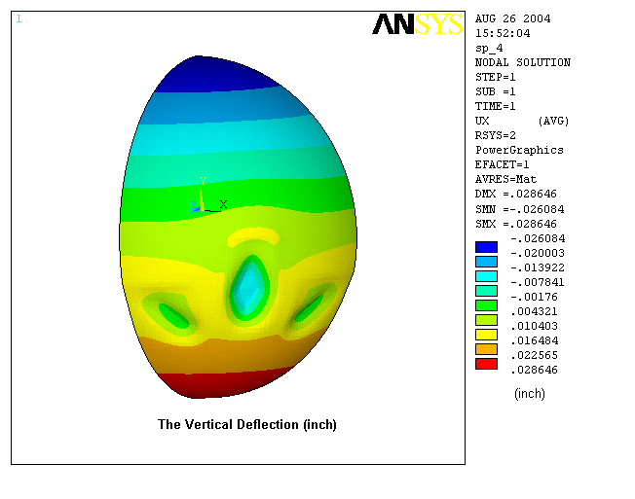
Figure 3 The Maximum Vertical Deflection of Sphere For Case I
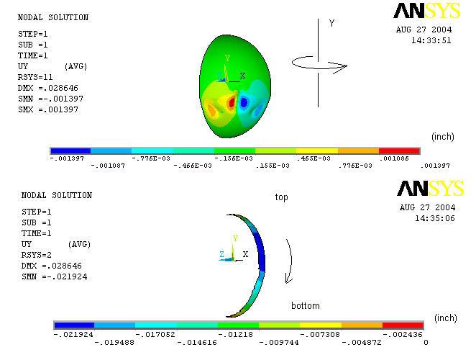
Figure 4 The Tangential Component (in-plane) of the Deflection for Case I
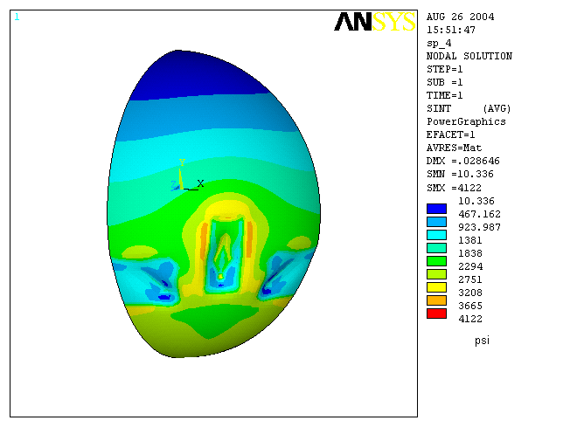
Figure 5 The Maximum Stress of the Sphere for Case I
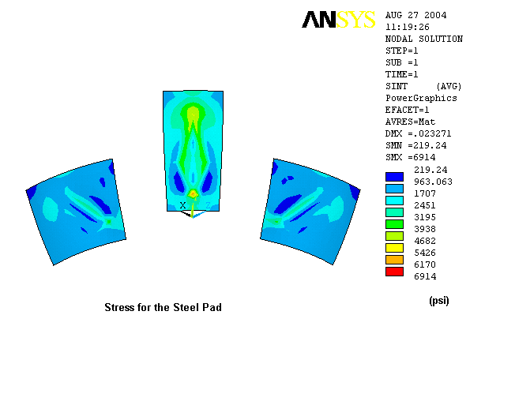
Figure 6 The Steel Pad Stress for Case I
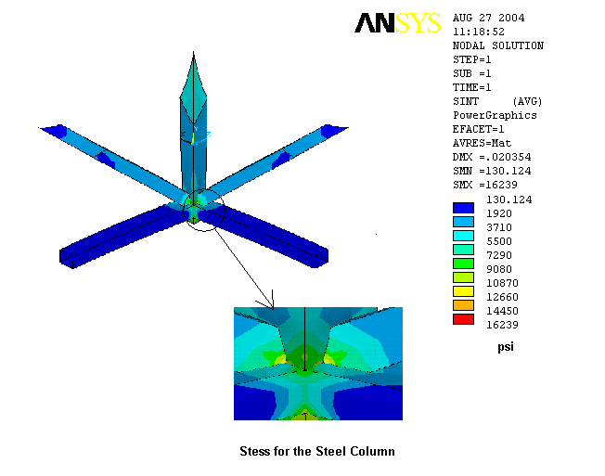
Figure 7 The Steel Column Stress for Case I

- Case II: One corner drops 1/16
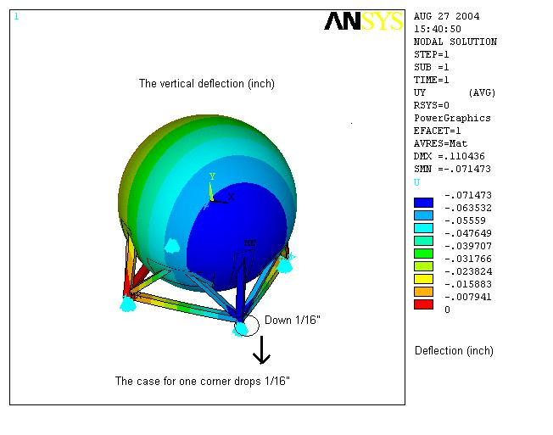
Figure 8 The Vertical Deflection For Case II
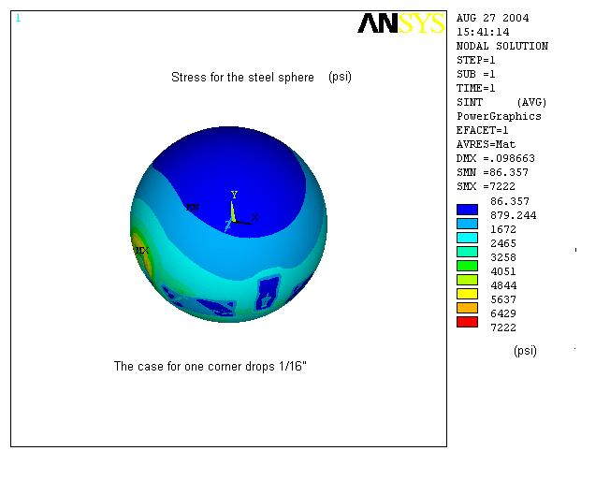
Figure 9 The Sphere stress for Case 2
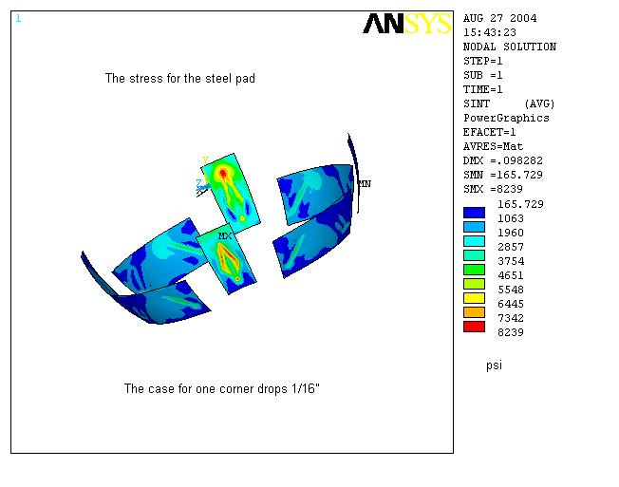
Figure 10 The Steel Pad Stress for Case 2
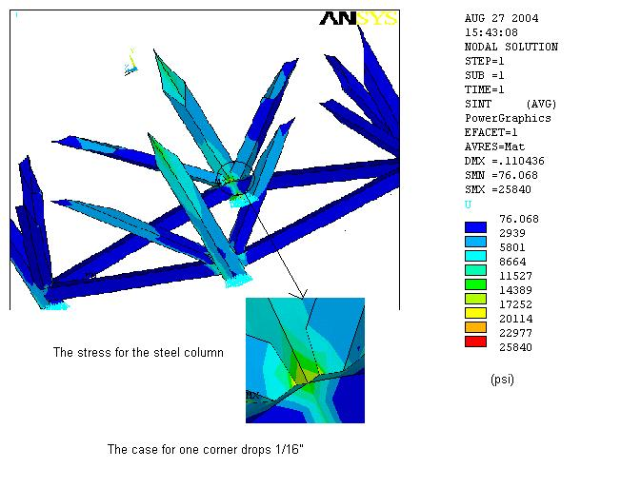
Figure 11 The Steel Column Stress for Case 2

3) Case III: One of supports completely drops out (three supports __accident case)
Figure 12 The Vertical Deflection for Case III
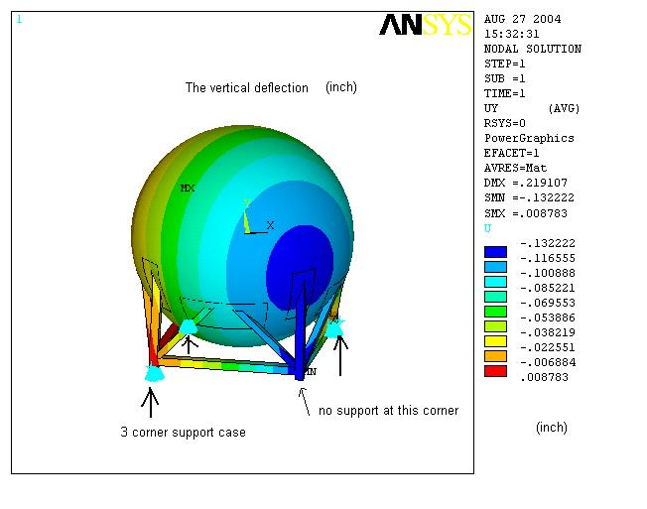
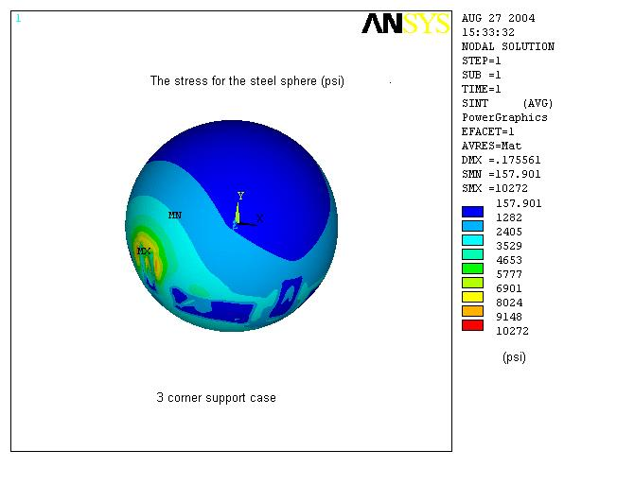
Figure 13 The Sphere Stress for Case III
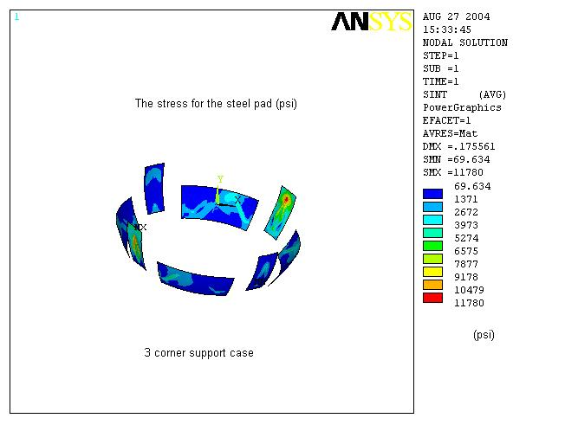
Figure 14 The Stress Pad Stress for Case III
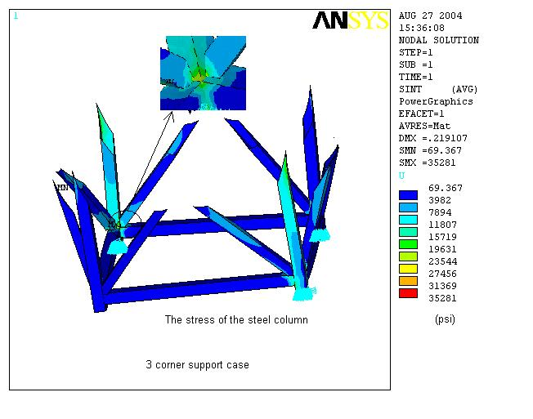
Figure 15 The Steel Column Stress for Case III

