Reactor Detector Baseline Design

Argonne National Laboratory
High Energy Physics

Victor Guarino, Jim Grudzinski, Ivars Ambats, Ken Wood, Emil Pereit

June 16, 2004

- Introduction
The Braidwood collaboration is designing a new experiment to be located at the Braidwood nuclear power plant to study electron antineutrino disappearance to measure of limit the important neutrino mixing parameter θ₁₃. The important features of the experiment design are to locate one 25 ton (fiducial volume) detector about 200 m from the average core position, and another two identical 25 ton detectors at a distance of about 1.5 km. Both detector sites need to be under sufficient overburden that muon induced spallation products do not produce a significant amount of correlated background, and are at the bottom of shafts with an overburden of at least 400 MWE.

Each detector is spherical and is separated into three volumes. The inner volume contains 25 tons of Gadolinium loaded liquid scintillator. The middle volume contains scintillator without Gadolinium. The outer volume, which also contains the 8 inch phototubes with 20% photocathode coverage, contains mineral oil.

Specification for overall Detector Design
Inner material
Mineral Oil Based Liquid Scintillator, such as Bicron BC-517S, loaded with 0.1% (by weight) Gadolinium. We need to know the number of Hydrogen atoms per cubic centimeter to 0.2%.
Middle material: Mineral oil based liquid scintillator without Gadolinium
Outer material – mineral oil without scintillator

In all three liquids, we need to maintain an attenuation length of 6 meters or longer.

Phototubes: 8 inch phototubes such as Hamamatsu R7081, with a pointing accuracy of 5 degrees or better.

- Detector Design
The basic dimensions of the detector are shown in Figure 1. The detector consists of 3 concentric spheres filled with liquid scintillator. The two inner spheres are acrylic and the outer sphere is steel and supports the PMTs. The outer steel sphere is constructed in two halves and joined at a bolted flange. This allows the detector to be disassembled so that the PMT tubes can be accessed.
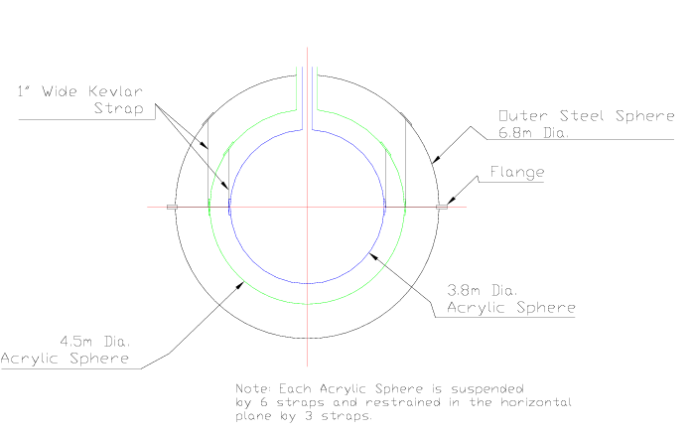
Figure 1
Schematic of Detector Geometry

There is a steel tube structure which supports the outer steel vessel (not shown in Figure 1). This structure supports the detector and provides a system to move it on rails as well as lifting it.

The basic premise of the design is that the spheres are filled so that there is a constant level of liquid in all three spheres; therefore no structural elements are needed inside the detector. The acrylic spheres are supported by six vertical straps and 3 horizontal straps. The acrylic spheres and vertical support straps only see a load of the weight of the spheres and not the liquid scintillator because all three spheres will be filled together.

The basic assumptions that drove the design of the detector are:
- Components of the detector will be constructed off-site where adequate clean rooms and crane capacity exist.
- The liquid scintillator will be mixed on-site and the detector filled from common storage tanks.
- The detector will be lowered into the pit while full of liquid scintillator.

  - Designing with Acrylic

The primary requirement for the inner sphere material is that it is optically clear. An equally important requirement is that the material be able to withstand the applied loads from the contained liquid. Three common materials can be considered: Laminated glass, Acrylic (PMMA, Plexiglas®) and Polycarbonate (PC, Lexan®). While similar in that all of the materials are transparent, they each offer unique attributes that make them more ideal for certain situations (similarly there is variance among each type to accommodate specific applications such as higher impact acrylics or higher clarity polycarbonates. Glass is relatively scratch resistant compared to the polymers (especially polycarbonate which scratches easily) and remains clear over time whereas acrylics and polycarbonates yellow in time when exposed to UV light. An additional concern with glass is that it often contains trace amounts of K₄₀ which can contribute unwanted background through emission of gamma particles.

Laminated glass also has the highest strength and stiffness which is desirable especially when sizing large windows for aquariums resulting in lower thickness windows compared with the polymers. The main drawback to glass is that it is very brittle. Tempering can increase the fracture toughness of glass by 4 times. For added safety, several thin sheets are laminated into a thick sheet with a high strength interface material added between sheets. This prevents a crack in one area from penetrating through thickness as it is arrested by the interface material. The window is designed with a margin of safety such that one layer of glass can fail without causing the window to fail as a unit. Design using glass cannot allow stress concentrations as these lead to cracking. Even with minimizing stress in the glass, assurance against failure can only at best be expressed statistically. The low impact strength also raises a concern during service and transport where impact loads from dropped tools or other harmful action could cause fracture.

To have higher impact strength, acrylic and polycarbonate are generally used in place of laminated glass. While both materials should be considered as brittle materials (especially as compared to common structural steels), certain polycarbonates can offer 30 times higher fracture toughness values than acrylics. As mentioned above, polycarbonates are softer and scratch relatively easily. Additionally polycarbonates are generally less resistant to chemicals as compared to acrylic and this often is a deciding factor. In fresh water aquariums where windows are designed for stiffness, it is the higher stiffness of acrylic that results in that choice as the polymeric substitute for laminated glass. It is also noted that the AMSE PVHO (Pressure Vessel for Human Occupancy) standard allows windows made of acrylic only. It is also noted that the SNO collaboration chose to make their detector of polycarbonate though the exact reasons are not known to us currently.

At this point in the design, we focus on acrylic as the baseline material for the detector although we will continue to investigate properties and manufacturing methods of polycarbonate and laminated glass to confirm that this is indeed the best choice for this situation. Acrylic is chosen over glass for the higher impact strength and over polycarbonate for the improved chemical properties as well as a perceived endorsement by SNO and the ASME PVHO standard. Finally acrylic is chosen as a reputable and experienced manufacturer (Reynolds Polymer Tech) has been identified as well as some basic design guidance. A manufacturer has not yet been found for polycarbonate on the size scale that we need and further engineering knowledge is needed before laminated glass could be properly evaluated.

 | R-cast® (PMMA) | Lexan XL10
Tensile Stress [MPa] | 72.4 | 65.5
Tensile Modulus [GPa] | 3.01 | 2.4
Ultimate Flexure Strength [GPa] | 110.3 | 93
Compressive yield strength [MPa] | 120.7 | 86
Compressive Modulus [GPa] | 3.01
Ultimate Shear Strength [MPa] | 68.9
IZOD Impact Strength [J/m] | 17.1 | 638
Water Absorption (24 hr) | 0.11%
Coefficient Thermal Expansion [μm/m/˚C] | 57.6 | 67.5
Refractive Index | 1.49
Luminous Transmittance | 91.0%
U.V. Light Transmittance | 1%
Table 1 Representative mechanical properties of acrylic and polycarbonate.

    - Considerations for designing with Acrylic
      - Yielding

The acrylic spheres are designed for strength. This reduces to designing against yield and fracture. Table 1 lists the tensile and compressive yield stresses of acrylic as available from Reynolds Polymer Company. Long term effects of creep and stress relaxation must also be considered in determining the correct safety margin to use along with these values.

      - Fracture Mechanics

Acrylic structures can fail at stresses lower than yield in a brittle manner due to unstable crack propagation [3]. Brittle fracture results from sharp cracks in areas of high stresses. Defects can be minimized with proper quality control and inspection can determine a largest undetectable flaw. This largest undetectable flaw is then assumed to exist and defines a critical stress intensity above which brittle failure would occur. The value of maximum stress is related to the maximum. General design practice is to reduce stress concentrations.

Using the fracture mechanics approach, the critical stress intensity factor is calculated using the equation [4]:

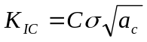 (1)

where

K_{IC} = 0.73 ksi (in)^{1/2} [for PMMA (acrylic)]
C = π^{1/2} [for wide plate in tension]
σ = nominal applied stress
a_{c} = critical flaw size resulting in unstable crack growth

For nuclear pressure vessels, the criterion known as leak before break is required. This detector does not fall under this jurisdiction, it is conservative to design in this fashion. This requirement means that the material should allow a surface crack (or indentation) large enough that it will grow completely though thickness before reaching critical crack size. A leak would then lower the pressure and also signal a crack allowing action to be taken before catastrophic brittle rupture would occur.

Assuming an existing slender (elliptical) surface flaw of length 2a (longest direction), the worst possible orientation for the crack is when the long direction is aligned perpendicular to the tensile load. This is also the assumption of equation 1. As the flaw grows, it will expand to a spherical shape becoming circular at the surface before lengthening any further. Assuming the material thickness of t, the hemispherical flaw will penetrate through thickness when the flaw size is 2t. Therefore, the leak before break criterion requires:

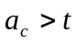 (2)

Since K_{IC} is given for the material, we use equation 1 to solve for the maximum allowable nominal stress. Using the values above along with the inner and midle acrylic sphere thicknesses of t=6mm and 12 mm, results in σ = 5.7 MPa and 4.0 MPa respectively. The current design stresses for the inner and middle spheres 4.4 MPa and 3.5 MPa respectively indicating a margin of safety for leak before break conditions.

It is also noted that equation 1 is for one particular crack geometry. The constant C varies for other geometries. Consideration must also be given to stress concentrations such as in the immediate vicinity of a hole which is 3 for round holes in infinite plates loaded in tension.

The previous calculation used a textbook value of the fracture toughness for PMMA. Because many varieties of PMMA exist (in much the same way alloys of steel vary), the value calculated above should be redone with a value characteristic of the actual material used. It is certainly possible that K_{IC} values are much greater for the commercially available acrylics. Unfortunately commercial suppliers of acrylic generally only publish IZOD impact test results which allow representative comparisons of fracture toughness between materials. These values however are strongly dependent on sample geometry used in the IZOD test and are not true material properties as K_{IC} is. We are currently unaware of a method of converting IZOD test values to K_{IC} values. At this time, the value of K_{IC} is not known and may ultimately require specific testing on our part.

      - Flaws defined by ASME PHVO standard defines

The AMSE PVHO-1 and PVHO-2 standards [1, 2], also define critical flaw sizes for acrylic windows during manufacturing and during subsequent service inspections. The formulas used do not clearly relate back to fracture mechanics principles described above. The standard instead specifies design geometries for windows and then also defines acceptable flaw sizes based on geometry. Instead of using the material fracture toughness, the specification dictates a minimum IZOD impact energy for material used. Presumably, experience and other empirical relations have factored into this determination. Although this has not been done at present, the above fracture mechanics principles should be applied to a design as specified by the PVHO standard and compared. In this method, an apparent safety factor can be determined from the code and compared to that used for the detector design.

      - Sources of cracks Inspections
Independent of the criteria used to determine the critical crack sizes, the detector needs to be inspected for cracks and flaws both after manufacture and during it service lifetime. Even if no flaws are found prior to service, there are several sources that can cause crack initiation. These include chemical attack, thermal gradients, and load fluctuations (fatigue).

The PVHO standard defines an inspection criteria for in service use which serves as a useful guide for periodic inspection of the detector components. In particular, if at any time the detector is service, potential flaws may be incurred through accidental tool contact for example. One benefit of using acrylic in spite of the brittle nature is that crazing tends to occur prior to crack propagation giving an indicator of potential problems. In some cases as defined by the PVHO standard, discoverd flaws can be repaired so that there effect is mitigated.

      - Chemical attack

Chemical exposure to acrylic can cause problems with stress corrosion where subcritical cracks can develop and propagate to critical size. Generally the manufacturer can advise if a compatibility problem exists. As the use of pseudocamine doped mineral oil scintillator is unique to the physics community, this knowledge might not be readily available. Testing should be undertaken to determine if a long term exposure problem exists.

      - Assembly

The large sphere object will be constructed of multiple curved panels to form the sphere. Casting is the preferred method over thermoforming as the latter alters the physical properties of the polymer in an unfavorable way. Additionally, casting is the only method allowed when following the PVHO standard.

    - Bonding
Reynolds Polymer has expressed concerns with the existing design with regard to finishing the bond line interior to the sphere when the two hemispheres are assembled. This unfinished bond is structurally sound but produces and area immediately adjacent to the bond line that is not transparent to light. This area has not been quantified and further discussion is needed to come up with design alternatives that might eliminate this bond line problem.

The SNO experiment has developed great experience in creating spheres made up bonded panels. One difficulty that has been relayed from an individual involved in Sno [7] results from the exothermic process and shrinking of the bond line as the bond cures. Care must be exercised in providing as much flexibility for joined panels as possible allowing movement during the cure process and reducing residual stress. Poorly done joints can result in craze initiation and require rework. This bond process increases in difficulty as he sphere gets built up as the panels become increasingly constrained. The experience gained in construction of the sphere is documented partially in SNO notes but primarily in an on-line logbook of the collaboration. We are currently trying to gain access to this volume of information which would provide critical insight and reduce our learning curve dramatically.

  - Detector Structural Analysis
The structural analysis examined three loading scenarios:
- Empty and being moved
- During the filling process and when the detector is full of liquid scintillator and stationary
- Full of liquid scintillator and moved on a truck/lowered into the cavern.

The requirement that the detector will be filled/emptied so that the liquid level is the same in all three spheres results in the acrylic spheres and support straps only have to support their own self weight. The entire weight of the spheres and liquid scintillator is supported by the outside steel sphere.

The following ASME structural codes were used to guide the design of the detector and establish safety factors:
- BPVC-VIII-2001 Rules for Construction of Pressure Vessels Division 1
- 2003 Safety Standard for Pressure Vessels for Human Occupancy
- PVHO-2-2203-2004 : Safety standard for pressure vessels for human occupancy : in-service PVHO acrylic windows guidelines

    - Structural Analysis and Fabrication of Acrylic Spheres
Section 2.2 above discussed the acceptable levels of stress in acrylic when it is used as a structural element. If the liquid level is controlled the during the filling/emptying process the two acrylic spheres will never support the weight of the liquid scintillator, but will only have to support their own self weight. However, for the purposes of design, the thickness of the acrylic spheres was determined by doing a structural analysis as if the spheres had to support the entire weight of the liquid scintillator inside of them. The calculations for this analysis are shown in Appendix 1. The inner acrylic sphere will be 10mm thick and the outer acrylic sphere will be 14mm thick. The maximum stress in the acrylic is 438psi which is a safety factor of 14 when compared to the nominal strength of acrylic. This high safety factor is consistent with the ASME codes which are used as guidelines for designing acrylic structures.

Each acrylic sphere will be supported by six vertical straps and three horizontal straps. The purpose of the vertical straps is to support the weight of the acrylic sphere alone while the horizontal straps maintain the location of the sphere during transport. The inner sphere weighs 315kg and the outer acrylic sphere weighs 1,007kg. It is felt that no additional straps are needed at the bottom of the spheres to anchor them and that the spheres self weight is enough to insure that they will not float. A schematic of the straps is shown in Figure 2 below and details of the strap fixture which will be glued onto the acrylic spheres are shown in Figure 3.

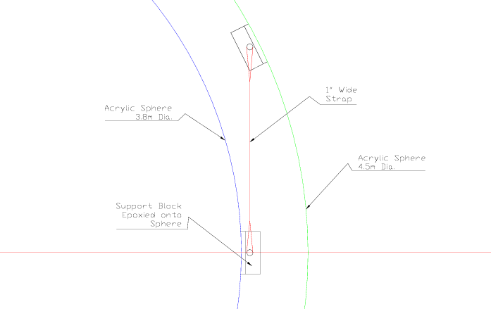
Figure 2
Acrylic Sphere Strap Support

A test report from SNO (SNO-STR-91-3 Acrylic Mechanical Bond Tests) indicates that bonds of approximately 6,000psi can be achieved which is approximately the same strength as the base material. Using the rough number rough number of 6,000psi for bond strength it is calculated that the strap fixture can support 2 tons with the limiting factor not being the bond but rather the 1” diameter rod that supports the strap. By increasing the cross section area of this rod it is possible to increase the load carrying capacity of the strap connection. However, the 2 ton capacity is far in excess of what is needed to support the weight of the acrylic spheres.

Each sphere will be constructed from segments and joining them together in a manner similar to SNO. The SNO sphere was approximately 12m in diameter and was composed 130 separate pieces with 1500 ft. of bond. The SNO sphere was constructed by Reynolds Polymer Technology and the size of the panels that were used was restricted by access to the underground cavern where the detector was assembled. A similar restriction does not exist for this experiment; therefore, it is possible to construct the sphere from the largest panels that Reynolds can fabricate. Figure 4 shows the inner sphere constructed from 11 different segments. It is desirable to construct the spheres from the largest segments possible to avoid making additional bonds. The epoxy bonds create problems of shrinkage which induce stress into the structure. These stresses then have the potential to lead crazing over time. Detailed drawings of the panels have been developed and ANL is currently in discussions with Reynolds to determine the best method for fabricating the spheres.
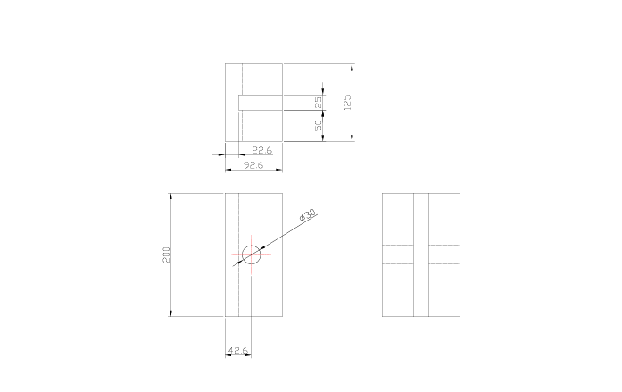
Figure 3
Details of Strap Fixture

Assembly of Spheres
The inner sphere will be completely assembled at ANL where there are existing clean room facilities with the needed crane capacity. Also at ANL the two half spheres of the outer acrylic sphere will be assembled. The complete inner sphere and the two half spheres are then transported to the Braidwood site 35 miles away. The transport of the spheres is discussed in a section below.

One critical aspect of the sphere assembly that was discovered in detailed discussions with Reynolds was that each bond joint had to be polished from the inside of the sphere. For the inner sphere it could be possible to polish all of the joints if the last joint is the attachment of the 20” diameter tube which makes the chimney. If the top dome is sized correctly it should be possible to reach inside the 20” diameter hole for the tube and perform the polishing on the top dome. Since the chimney is basically a dead area in the design if the joint between the tube and the sphere is not polished on the inside then not much is lost. The outer acrylic sphere, however, is a different story. This sphere must be assembled in two halves in order to enclose the inner sphere. As a result it is not possible to polish the inside of the last joint that will run around the center of the sphere. However, this joint should be approximately no more than ¼” wide. Further discussions and tests are needed to determine the optical quality and area affected by a joint that is not polished on the inside.

A critical aspect of the sphere assembly is the quality of the epoxy bond joints. SNO apparently experienced significant problems with joint shrinkage during assembly. By making the largest possible panels and assembling those together off-site it is possible to control this process better and minimize joint shrinkage and any resulting residual stresses which could result in crazing over time.

The acrylic spheres will be assembled together and then placed in the outer steel sphere in the sequence of moves shown in Figure 5 and described in detail in Section 3.2 below.
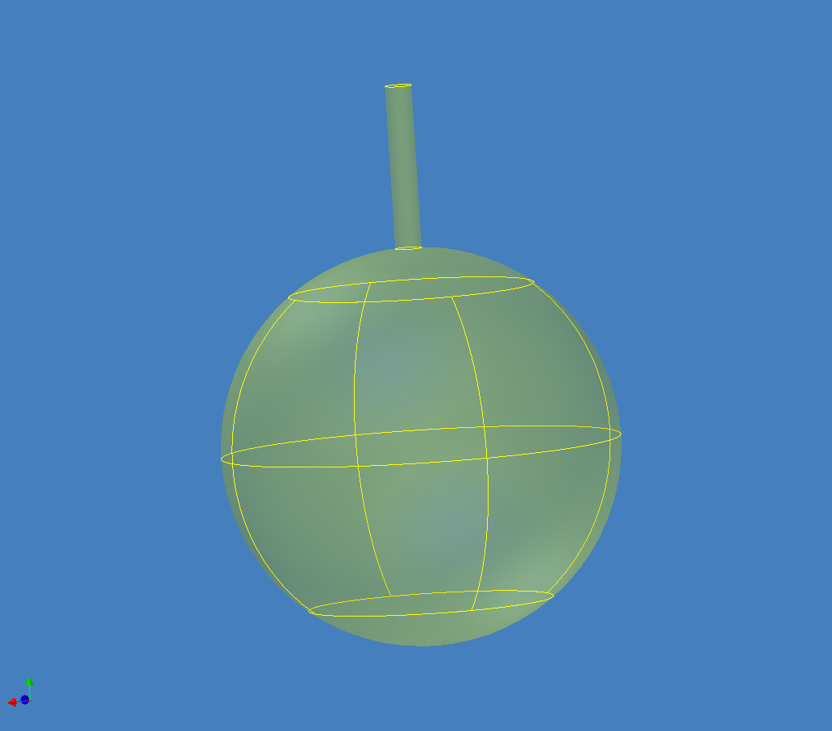
Figure 4
Inner Acrylic Sphere Constructed from 11 Segments

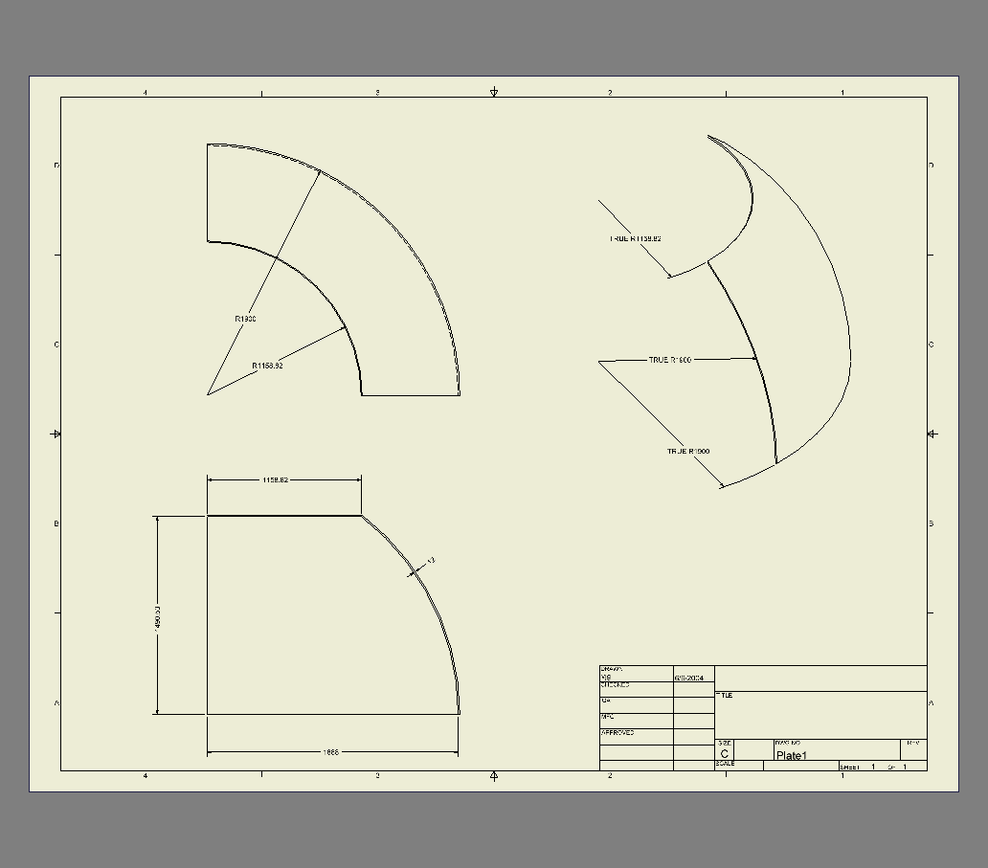

Figure 5
Detailed Drawings of Segments to Assemble Acrylic Sphere

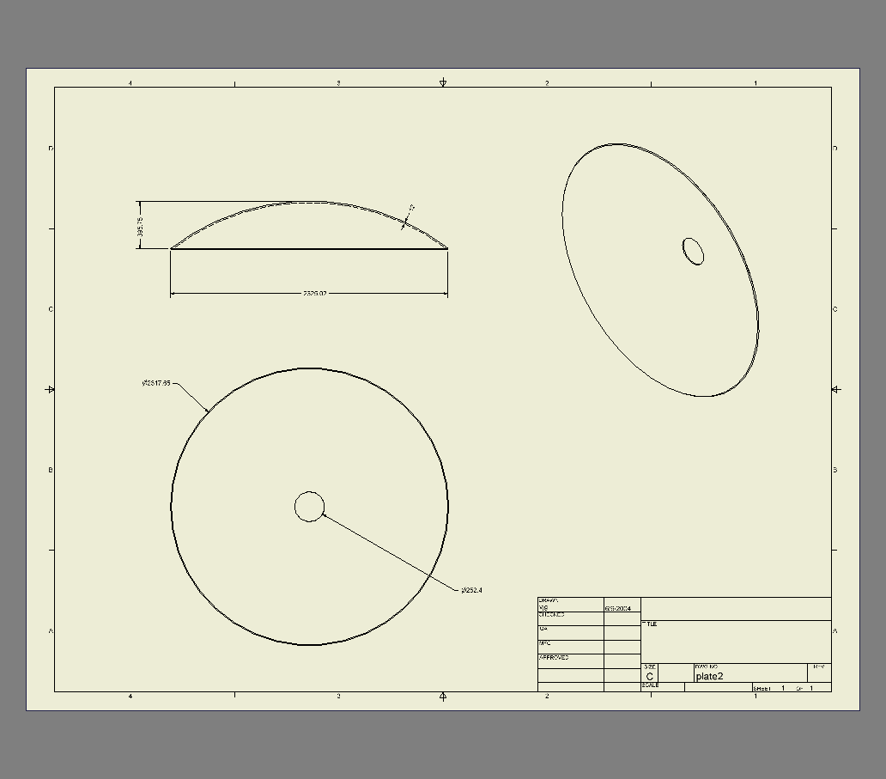
Figure 6
Detailed Drawings of Segments to Assemble Acrylic Sphere

    - Structural Analysis and Fabrication of Steel Sphere
The outer steel sphere supports the entire weight of the liquid scintillator. Calculations were done assuming that the steel sphere was supported at its mid-section and these showed that a 6mm thick wall is needed. Copies of these calculations are in Appendix 1.

The steel sphere supports the PMT and it is important to be able to have access to these for maintenance. Therefore, the steel sphere is constructed in 2 halves and bolted together at a flange. Details of the flange and sphere are shown in Figure XXX. A commercial spherical tank head will be used for each half sphere. Because of the large diameter (6.5m) of the half sphere only a small number of companies are capable of fabricating them. Also, shipping a half sphere that is 6.5m in diameter is a problem and even with a special permit it may not be able to ship such a large sphere over a long distance. It may be possible to fabricate the half sphere locally and then ship it a relatively short distance (30-40miles) to the Braidwood site. Six different manufacturers of spherical heads have been contacted and only one was willing to provide a budgetary cost estimate.
Odem Industries putting together an estimate to fabricate a half sphere. However, this half sphere would be shipped in 2 pieces and would have to be final assembled on site or at a site close to Braidwood. This presents a problem for attaching the flange that is needed to connect the two halves together.

An alternative to a spherical tank could be a more simple structure that is simply a large cylinder with a top and bottom. This is very similar to a gasoline storage tank or above ground pool in shape. Such a structure would be much simpler to fabricate and get access to. Inside this tank a geodesic dome similar to what was used for SNO could be built to support the PMTs.

    - Structural Analysis of Support Structure
Figure 7 and 8 show the front and top views of the support structure for the outer steel sphere. This structure is constructed from 6” x 6” structural tubing. Because of its size it is constructed in four separate sections (which are shown in Figure 7 and 8) and bolted together on site. This structure is supported on 3 sets of Hilman rollers. The rollers will run in an inverted U-channel which will be on the floor of the tunnel. This structure was designed to minimize deflections of the steel sphere so that no external loads are put on it during movement. A finite element model of the structure was constructed using beam elements. The deflection plot of this model is shown in Figure 9. The maximum deflection of the structure occurs at the center and is .1”. All of the stresses are within acceptable limits.

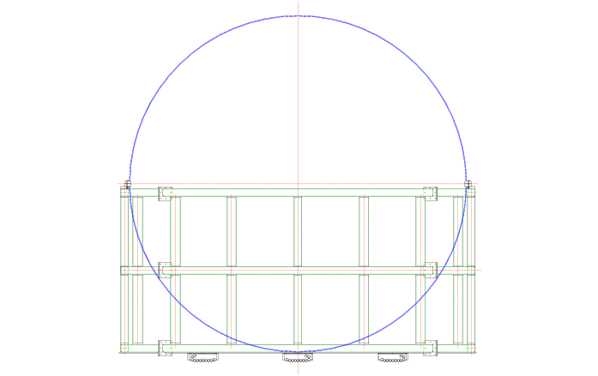

Figure 7
View of Support Frame on Hilman Rollers with Steel Sphere

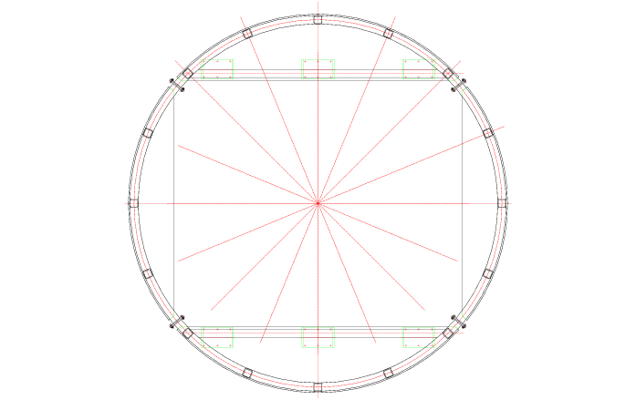
Figure 8
Top View of Support Frame with Steel Sphere

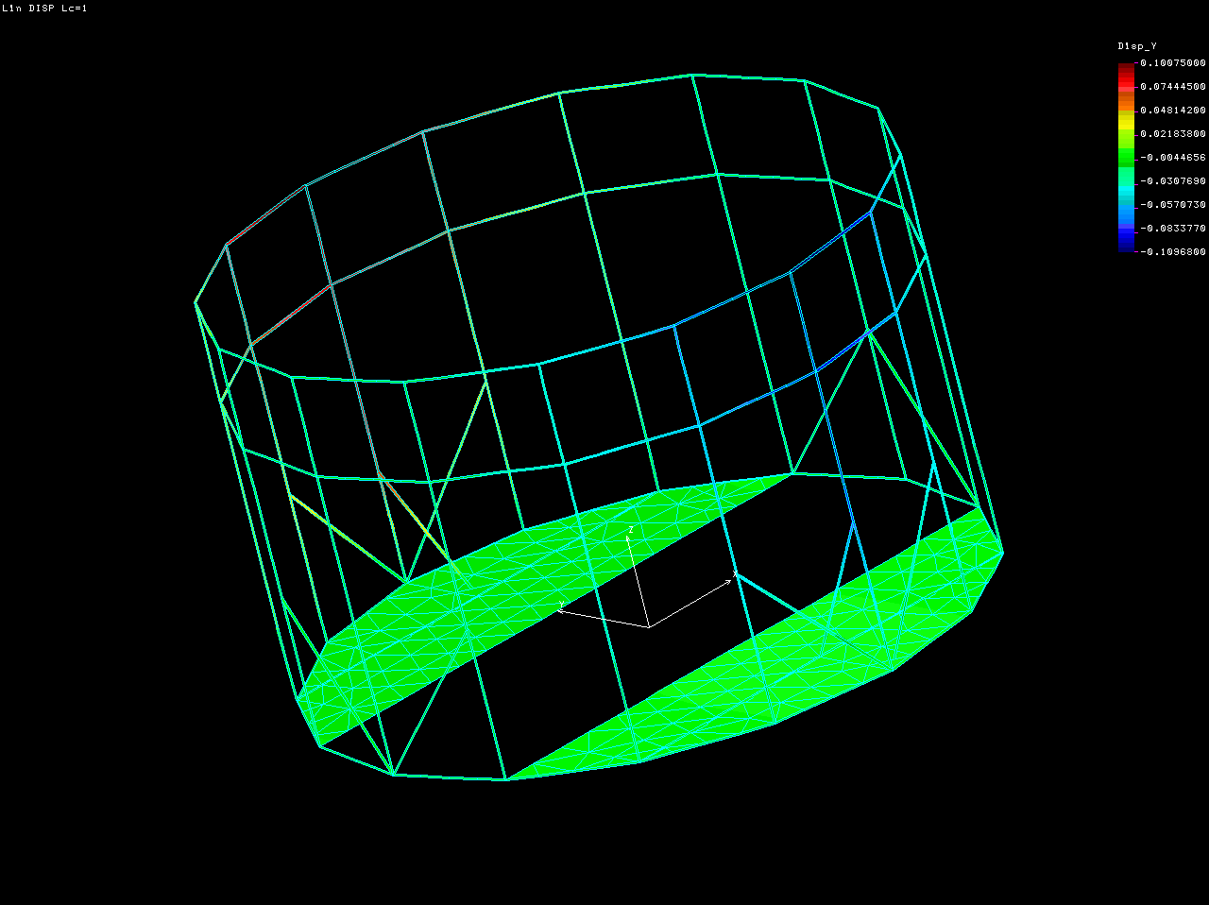
Figure 9
FEA Deflection Plot of Support Frame

    - Structural Analysis of the Movement of the Detector
There are several movements of the detector that have to be examined that are listed below:
- Movement in the tunnel on the Hilman rollers when full of liquid scintillator.
- Movement between the near and far detector sites when full of liquid scintillator.
- Movement of the detector when empty.

Movement on the Hilman rollers:
The detector will be moved on Hilman rollers. There will be a total of eight 50 tons rollers. These rollers will be guided in U-channels that are grouted to the floor of the cavern. Hilman recommends that 10% of the total weight is used as a design force for pushing moving the detector using the rollers. The experience on CDF and STAR is that a force of only 5% of the total weight was needed to move the detector. Currently the HEP division at ANL is designing a similar movement system for the 1,000 tons Atlas detector at CERN. A test setup is at ANL that is being used to move some dummy weights with hydraulic cylinders that have a total capacity of 15 tons. These cylinders could be used to move the REACTOR detector in the cavern.

Affect of Movement on the Liquid Scintillator
There is potentially an increase in pressure inside the sphere when the detector is moved.
As an initial rough estimate of how the pressure in the sphere would increase was made using basic fluid dynamic equations below.

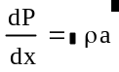
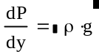
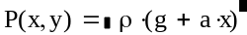

Solving for P in terms of x and y:

X and Y are the horizontal and vertical position in the sphere respectively and “a” is the horizontal acceleration of the sphere. For a 1g acceleration the variation in the pressure around the inside surface of the steel sphere is shown in the figure below.

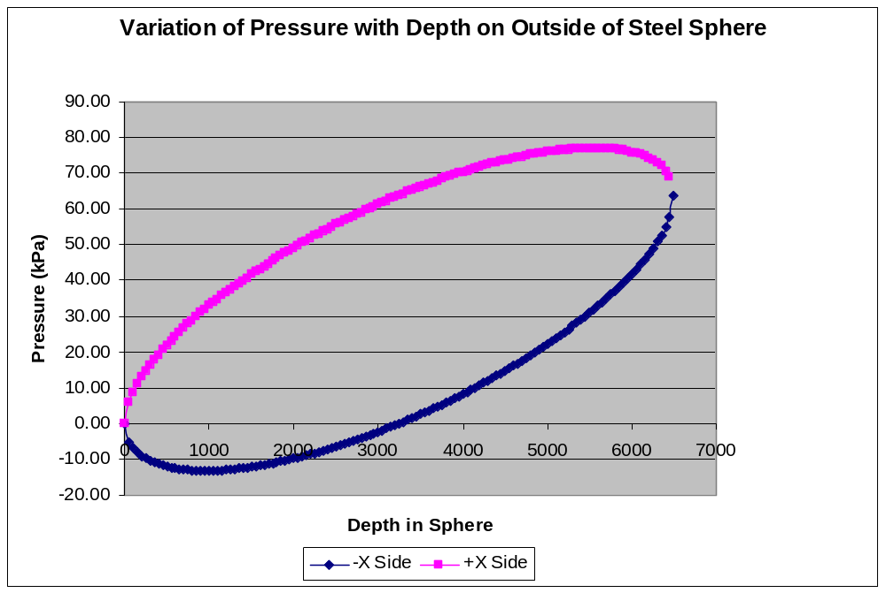
Figure 10
Variation of Pressure for a 1g horizontal acceleration.

The pressure at the bottom of a stationary sphere is 63.7kPa but this increases to 77kPa when the sphere is accelerated to 1g. This is an acceleration value that is typically used in calculations for the movement of equipment by truck or rail. However, in the REACTOR experiment it should be possible to control the acceleration and keep it below 1g. Further calculations are needed to see the affect of the increase in pressure that could occur due to acceleration and any possible affect on the PMTs of a resulting shock wave.

  - Filling and Draining the Detector
The physical construction of the detector requires attention to the buoyancy of the acrylic spheres as the filling progresses so that the sphere vertical support straps always see a positive load but not more than the weight of the sphere itself. As each acrylic sphere is met by the rising liquid outside it, its fill is initiated and maintained at a rate to keep the same liquid level. This results in different and variable fill rates for each spherical volume. For example, if the outer volume is filled with mineral oil at a constant rate, then the two acrylic spheres will have to be filled with the varying rates as graphed below:

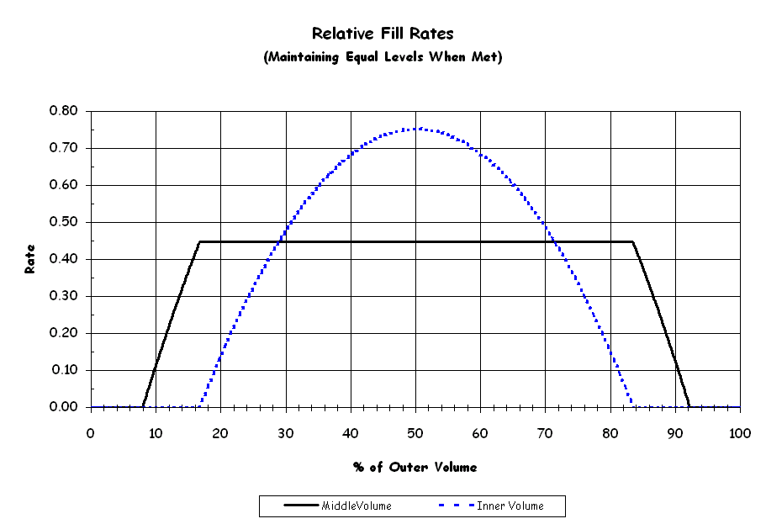

(This is for idealized spheres of diameters 3.8m, 4.8m, and 6.5m, with no dead volume and no chimneys.) It can be shown that the fill rate of the middle volume is constant in the vertical zone of the inner sphere and is equal to [(b²-a²)/(c²-b²)] = 0.447 in this example where a,b, and c are the diameters involved.
The filling process will occur in the above ground facility at the far detector site where the tanks for the liquid scintillator will be kept.

Each acrylic sphere can be filled or drained by pumping the liquid through a hose inserted through the top chimney. The steel sphere will have a bottom drain for this purpose. Bottom drains for the acrylic spheres are not desirable because of difficulties in joint sealing and in physical access.

  - Control of the Liquid Level
A control system will be used to insure that the liquid levels are kept even throughout the filling of each detector so that the load from the liquid scintillator will be completely supported by the outside steel tank. There will be level sensors in each sphere that will provide input to an automated pumping system. Positive displacement pumps will be used to measure the dispensed liquid amounts. Accurate flowmeters of the vortex shedding or mass flow/btu type will be used with flow totalizers and batch controllers under microprocessor control.

- Detector Assembly
The detector will be assembled offsite at Argonne which has the clean rooms and crane capacity that is needed to perform this delicate operation. The construction of the acrylic spheres will be done by an outside company which has expertise and experience constructing large acrylic structures. ANL will oversee the construction of the acrylic spheres and will be also lead the fabrication of the outer steel sphere and surrounding support structure.

  - Detector Fabrication Outline
Figure 11 below shows the section of assembling the spheres together. The inner acrylic sphere will be completely assembled first. The top and bottom half spheres of the middle acrylic sphere will then be assembled separately. The top half of the middle sphere will be lowered onto the inner sphere and the straps would be attached. The top half would then be lifted and place on the bottom half of the middle acrylic sphere and bonded together. This sequence of steps would then be repeated for assembling the acrylic spheres inside of the outer steel sphere.

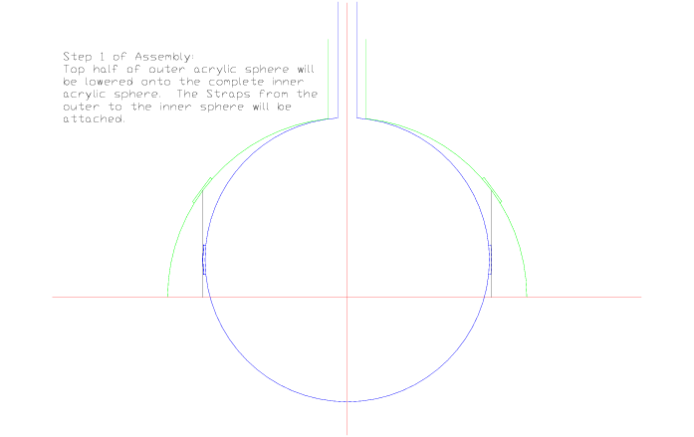

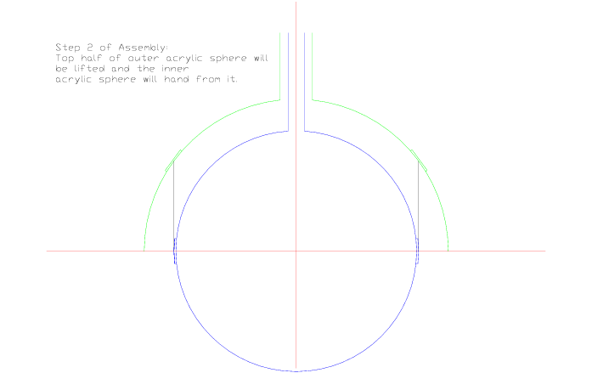

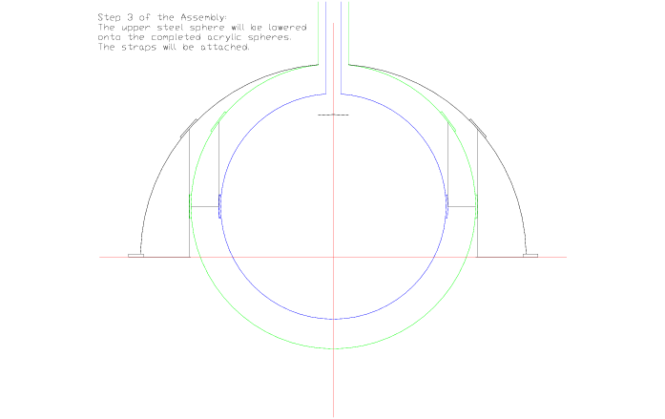
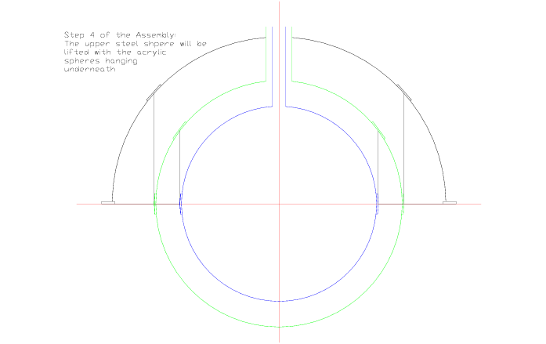

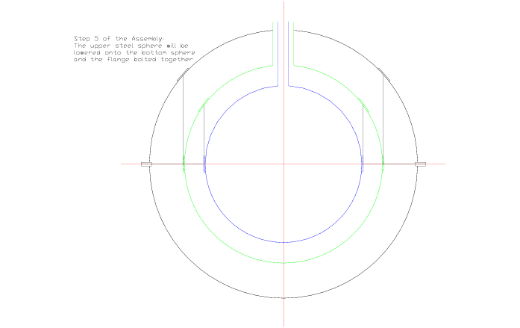

Figure 11
Assembly of Spheres

  - Cost of Detector Materials and Fabrication

- Liquid Scintillator
The inner volume of the detectors is chosen to be Gadolinium-loaded mineral oil based scintillator (such as Bicron BC-525); the middle volume to be mineral oil based scintillator (Bicron BC-517L); and the outer one of solely mineral oil. The quantities involved are approximately 29 m³ each of the inner two, and 144 m³ of the outer (for each detector).
Important properties to be specified, monitored, and controlled for these liquids include:
Low reactivity with detector materials (vessels, piping, co-existing hardware)
Long attenuation length (320 to 600 nm range) - >6m
Time stability of optical and physical properties
Low absorbed oxygen and water vapor
Optimized hydrogen fraction for the inner volume

  - Safety Hazards/ Environmental Concerns
Representative MSDS’s show some flammability hazard and moderate health hazard of the scintillator products. Spill protection is paramount under environmental concerns. The large volumes involved dictate that these hazards are explicitly addressed by written procedures at each step of handling the liquids: receipt, transfer, and testing. Handling procedures must be done by trained personnel and be strictly enforced. Personal protective equipment should include chemically resistant gloves and splash goggles.
The underground sites must be assessed as potential confined spaces. The aromatic constituents of the detector liquids are the primary health hazards when present as vapors. General ventilation to the outside should be implemented to reduce the personnel exposure as well as the fire risk from accumulation of the heavier than air vapors. Emergency egress procedures might include self-contained breathing apparatus.

  - Mixing, Storage and Distribution
The optimum way of ensuring uniform properties throughout all three detectors would be to fill them concurrently, ideally under equivalent setups with precise metering so that delivered volume is accurately known. This would suggest having three large storage tanks on site that would receive the total fill quantity of each of the three liquids. The tanks would have to be approximately 23,000 gallon capacity for each of the scintillator liquids, and 68,000 gallons for the mineral oil. (For reference, a rail tank car may be up to 25,000 gallons; a truck tanker is approximately 6,000 gallons.) The distinct advantage of this scenario is that any desired mixing, purification, filtering or gas purging could be done on the entire tanks to attain uniformity before filling any detectors.
Each storage tank will be filled by a number of truck-tanker deliveries of the specified product. Each delivery load will be monitored for compliance to the contract specifications before being pumped into the storage tank. The transfer may involve filtering and purification of the liquid (for water and particulate contaminants). The tanks will maintain a constant purge of the gas volume to eliminate oxygen absorption by the liquids, and there will be a circulation system for mixing the contents to attain a homogeneous content before distribution to the detectors. There may be temperature controls of the contents to avoid extreme ambient conditions.
To minimize systematic differences in the liquid properties between the three detectors, they will be filled simultaneously. This complicates the fill process as well as increases the cost. (The filling of each detector requires changing the flow rates of each liquid to maintain the same level.) Sequential filling of the three detectors may be considered.

  - Filtering/Circulation
There have been time-dependent effects observed on optical properties of some Gd-loaded scintillator. This may suggest that the target volume (at least) of a detector may have a circulation through some active filtering or replacement. This may however introduce systematic differences between the three detectors, so perhaps sampling and measurement of properties may be preferable.

  - Scintillator vendors
Two current vendors of Gadolinium-loaded (and non-loaded) mineral oil-based scintillator are Saint-Gobain (Bicron) and Eljen Technology. The Bicron BC-517L is an initial pick for the mineral oil based scintillator, with Bicron BC-525 as the Gd-loaded version. (Eljen Technology equivalents are EJ-321L and EJ-335.)

  - Scintillator Costs and Delivery
Recent cost estimates from Saint-Gobain:
- Mineral Oil @ $5/Gallon (~$1375/ton). This is in significant disagreement with a NOvA cost estimate of ~$2/Gallon ($556/ton) however, and the reason will be pursued.
- BC-517L @ $12/Gallon (~$3300/ton)
- BC-525 w/0.2% Gd @$50/Gallon (~$13,900/ton)

For a three-detector fill this would be:
$1,120,600 for 0.2% Gd loaded scintillator
267,800 for non-loaded scintillator
337,200 for mineral oil
or $1.725 Million for the total liquid fill.

We will pursue pricing for on-site mixing of both scintillator types, wherein the mineral oil is bought directly from manufacturers, and the scintillator and Gadolinium components are bought from the vendor

Below are some costs that were obtained for the NOVA experiment:

1. Mineral oil, one @ $1.80/gal and another at $2.03/gal
It's still not clear if this includes transportation -- one message
says it does, another says it doesn't.
The $1.80 turns into $ 553 per ton.

2. Fluor (pseudocumene + unknown small concentrations depending
on vendor of PPO and POPOP)
One guy at $ 6,000 - $ 9,000 per ton (in 55 gallon drums!)
Another guy at $ 6,900 - $8,000 per ton in tanker trucks

- Detector Transport
The detector at its widest is 6.5 meters. This is beyond the maximum width allowed for normal truck traffic. However, the Braidwood facility is only 40 miles from ANL and it is possible to get a special permit for such a wide load. Initial cost estimates show that it would cost approximately $5.4 to transport the largest half sphere from ANL to Braidwood. This quote includes the contract escort police escort, permits, and route survey.

At Braidwood the condition of the roads to each of the shafts would have to be evaluated as to whether they can support the load of a truck with the detector on it.

- Braidwood Site Facilities
The design of the facilities at the Braidwood site is based on the following assumptions:
- There is a permanent overhead crane at each detector site that has a capacity of 300tons and a travel of 40’x60’ and a length of lift of 550ft.
- The near and far detector site will consist of the shaft and a simple enclosure (40’x 60’) that will cover the shaft opening and the overhead crane.
- At the far detector site there will be office space available within the building.
- There are on-site storage tanks for the liquid scintillator.

The location of the near detector site and a layout of Braidwood are shown in the figures below

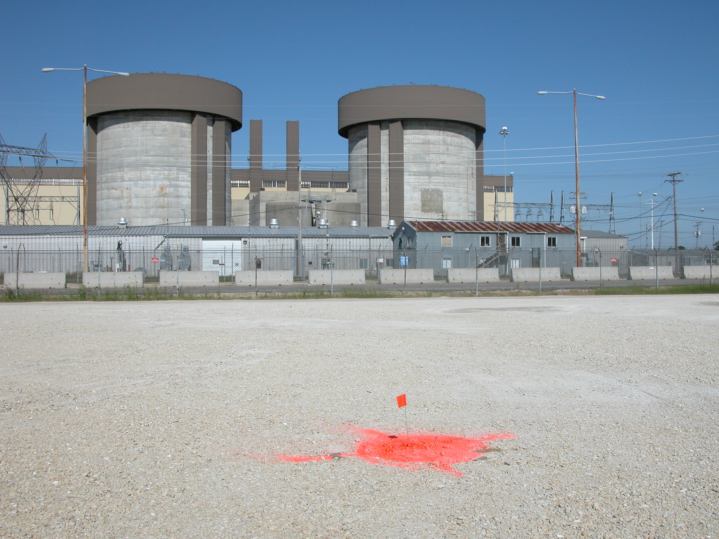

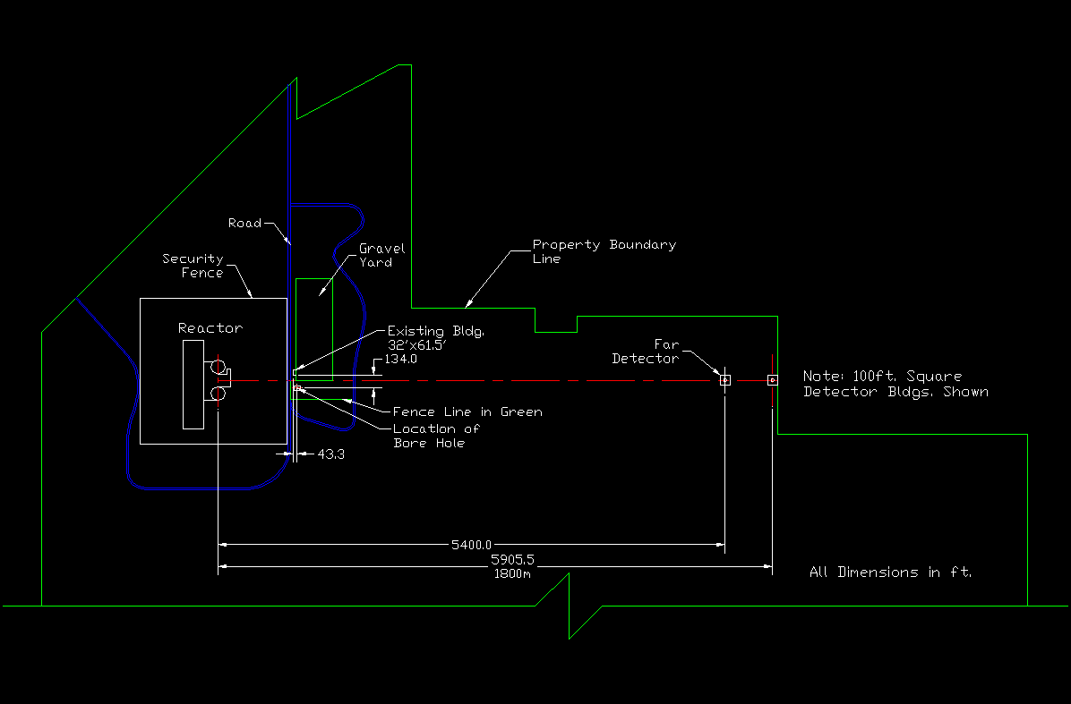

  - Crane Design
The near and far detectors will each have an overhead crane. The required travel of these cranes can be kept to a minimum by designing the buildings/crane so that a truck transporting the detector can drive directly underneath the crane. The crane can then lift the detector off of the truck and then, after the truck has pulled out of the building, place the detector on the floor. The crane then needs to be able to pick up the detector and translate approximately 8m (the max. width of the detector) to position the detector over the pit.

A quote for a crane has been obtained with the requirements detailed below:
- Span: 35’
- Length of Lift: 550’
- Lift Speed: Slow, up or down in an 8-hour day
- Building dimensions: 40’-60’

In discussions with several different crane vendors it was found that the 550’ length of lift was a limiting factor in which companies are capable of fabricating the crane. Most of the crane companies were interested in only supplying a standard crane with much shorter lengths of lift. Also, the speed of the crane was a price driver. By having a very slow crane the size of the components was reduced, thereby reducing the cost. Finally, the rails and support structures were

Only one vendor has replied to our request for a budgetary quote at this time. Heilo Crane and Hoist in Warrenville, IL provided a quote for the crane described above for $1.4M for each crane delivered and installed. This quote includes both the bridge with hoist, and the rails and support structure.

  - Near Detector Building
The near detector building is a simple structure that simply protects the shaft opening and crane. This building is 40’ x 60’ which is large enough to completely pull a truck with the detector inside next to the shaft opening. The following were the requirements for the building in our request for budgetary quote.

- Steel building 40’ x 60’
- Concrete floor with a 25’ hole located off to one side.
- Utilities installed with lighting

A quote was obtained from Steel Building Systems in Plainfield, IL for $300k for this structure.

  - Far Detector Building
The far detector building is identical to the near detector building but it will also have an office facility. In order to reduce costs an outside trailer will be used for the office space. This type of trailer will have bathroom facilities and can either be rented or purchased.

Two quotes were obtained for a 10’ x 40’ trailer. Two quotes were obtained. Action Mobile Industries quotes $12.5k delivered and installed and McDonald Modular Solutions quoted $15.9 delivered and installed.

- Conclusion
This paper outlined the conceptual design for the REACTOR detector. This paper has identified two issues that need to be addressed in order to successfully design and build a detector. First, the size of the steel sphere limits the number of companies which can construct it. Also, the size limits transportation so that a majority of the construction would have to occur on site which will require fixturing and added cost. Second, the level of acceptable stresses in acrylic and the method of bonding are critical areas that need extensive further research.
References

[1] ASME PVHO-1-2002, Safety standard for pressure vessels for human occupancy, ASME, 2003.

[2] ASME PVHO-2-2003, Safety standard for pressure vessels for human occupancy in-service guidelines for PHVO acrylic windows, ASME, 2004.

[3] N. G. McCrum, C. P. Buckley, and C.B. Bucknall, Principles of Polymer Engineering,

[4] Barsom, J. M. and Rolfe, S.T., Fracture and fatigue Control in Structures, 3rd Ed., ASTM, 1999.

[5] Hertzberg, R.W. , Deformation and Fracture Mechanics of Engineering Materials, 4th. Ed. , J. Wiley, 1996,

[6] J.M. Wouters, P.J. Doe, Acrylic mechanical bond test, LA-SUB-93-213-1, 1991.

[7] J.M. Wouters, private communication, 6/08/2004.

Appendix 1 Calculation of Stresses in Acrylic and Steel Spheres

Input Parameters:
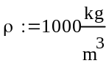

Inner Shell
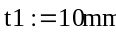
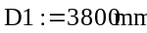
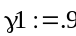
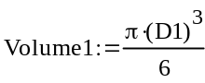
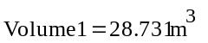
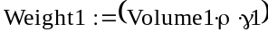
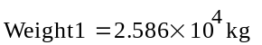
Middle Shell
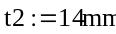
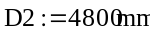
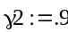
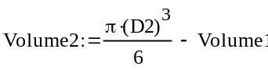
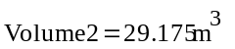
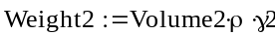
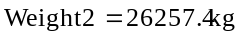
Outer Steel Shell
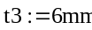
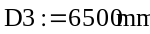
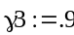
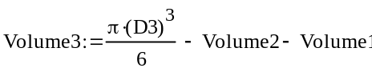
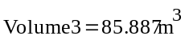
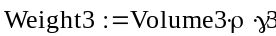
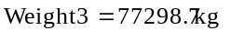
Total Volume and Weight

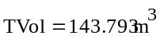

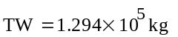
Calculation of Stresses in Each Shell
Shell is completely filled and supported tangentially at its Center ring
Spherical shell
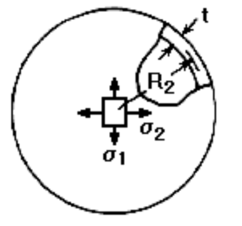
Filled to depth d with liquid of density, δ (force per unit volume), tangential edge support
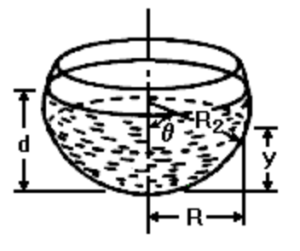

Enter dimensions for Shell 1, properties and loading
Shell thickness:
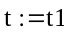
Angle from centerline to edge:
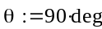
Mean radius:
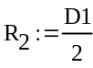
Modulus of elasticity:
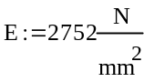
Poisson's ratio:
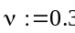
Depth:
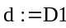
Liquid density:
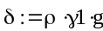
Distance from centerline to edge measured perpendicular to centerline:
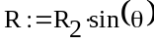
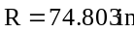
Height of section under scrutiny:
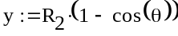
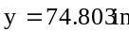
Note: For these equations to be valid, R2/t>10.
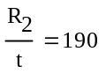

Calculation procedure
At any level below the liquid surface
Meridional stress:
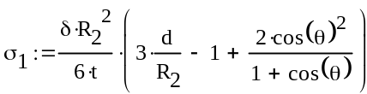
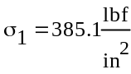
Circumferential stress:
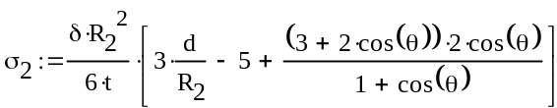
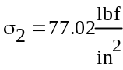
Radial displacement of circumference:
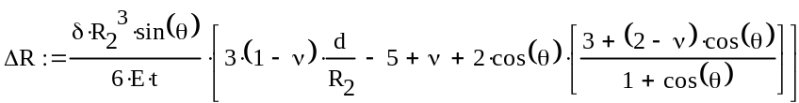
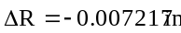
Change in height:
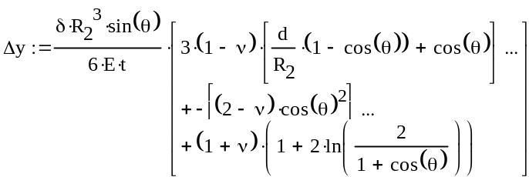
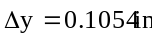

Rotation:
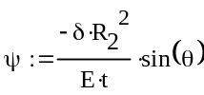
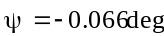
Weight of liquid:
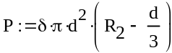
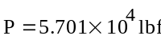

Enter dimensions for Shell 2, properties and loading
Assume middle shell supports the weight of inner shell as well
Shell thickness:
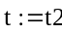
Angle from centerline to edge:
Mean radius:
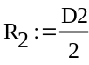
Modulus of elasticity:
Poisson's ratio:
Depth:
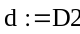
Liquid density:
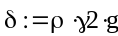
Distance from centerline to edge measured perpendicular to centerline:
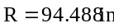
Height of section under scrutiny:
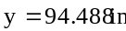
Note: For these equations to be valid, R2/t>10.
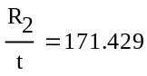

Calculation procedure
At any level below the liquid surface
Meridional stress:
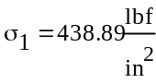
Circumferential stress:
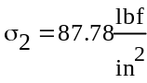
Radial displacement of circumference:
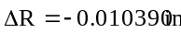
Change in height:
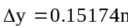

Rotation:
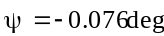
Weight of liquid:
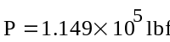

Calculation of the Outside Steel Shell
Enter dimensions, properties and loading
Shell thickness:
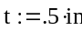
Angle from centerline to edge:
Mean radius:
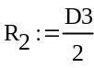
Modulus of elasticity:
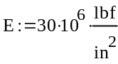
Poisson's ratio:
Depth:
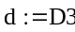
Liquid density:
Distance from centerline to edge measured perpendicular to centerline:
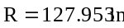
Height of section under scrutiny:
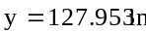
Note: For these equations to be valid, R2/t>10.
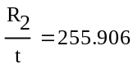

Calculation procedure
At any level below the liquid surface
Meridional stress:
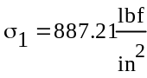
Circumferential stress:
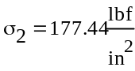
Radial displacement of circumference:
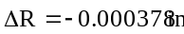
Change in height:
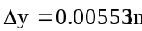

Rotation:
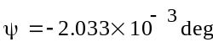
Weight of liquid:
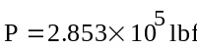

Plexiglas is a registered trademark of Atoglas , www.atoglas.com
Lexan is a registered trademark of GE plastics, www.geplastics.com
R-Cast is a trademark of Reynolds Polymer Tech, www.reynoldspolymer.com

